import pandas as pd
import pandas as pd
import material_fingerprinting as mf

# Load CSV
file_path = "~/Downloads/Paper 2 - Figure 8a CF.csv"
df = pd.read_csv(file_path)

# Show available columns
print("\nColumns found in CSV:")
for i, col in enumerate(df.columns):
print(f"{i}: {col}")

# Let user select columns
stretch_col = int(input("\nEnter column number for Stretch Ratio (λ): "))
stress_col = int(input("Enter column number for Cauchy Stress (kPa): "))

# Extract data
F11 = df.iloc[:, stretch_col].to_numpy()
sigma = df.iloc[:, stress_col].to_numpy()

# Convert Cauchy stress to First Piola stress
P11 = sigma / F11

# Create measurement
measurement = mf.Measurement(
"uniaxial tension/compression",
F11,
P11
)

print("\nRunning Material Fingerprinting...\n")

# Discover constitutive model
mf.discover([measurement])

Paper 1 Figure 4b F
Paper –

Dataset –

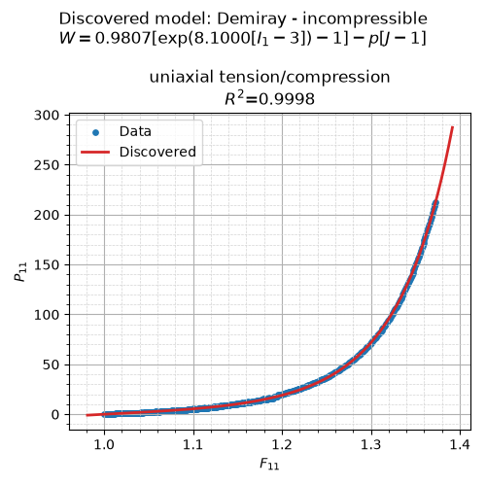

=== Material Fingerprinting ===
Contact moritz.flaschel@fau.de for help and bug reports.
The pickle database is loaded from the package resources.
Database Information:
models in the database:
Blatz-Ko - incompressible
Demiray - incompressible
Gent - incompressible
Holzapfel - incompressible
Mooney-Rivlin - incompressible
Neo-Hooke - incompressible
Ogden - incompressible
number of fingerprints = 2502
uniaxial tension: stretch ranges from 0.1 to 10.0 in the database
Material Fingerprinting Results:
discovered model: Demiray - incompressible
identified parameters: [0.98073857 8.1 ]
formula: $0.9807 \left[\exp(8.1000 [I_1 - 3]) - 1\right] - p [J-1]$
R² values per experiment:
uniaxial tension/compression: 0.9998
R² average over all experiments: 0.9998

Paper 1 Figure 4b CF
Paper –

Dataset –

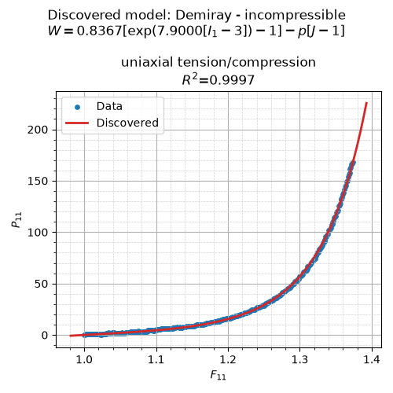
=== Material Fingerprinting ===
Contact moritz.flaschel@fau.de for help and bug reports.
The pickle database is loaded from the package resources.
Database Information:
models in the database:
Blatz-Ko - incompressible
Demiray - incompressible
Gent - incompressible
Holzapfel - incompressible
Mooney-Rivlin - incompressible
Neo-Hooke - incompressible
Ogden - incompressible
number of fingerprints = 2502
uniaxial tension: stretch ranges from 0.1 to 10.0 in the database
Material Fingerprinting Results:
discovered model: Demiray - incompressible
identified parameters: [0.83666703 7.9 ]
formula: $0.8367 \left[\exp(7.9000 [I_1 - 3]) - 1\right] - p [J-1]$
R² values per experiment:
uniaxial tension/compression: 0.9997
R² average over all experiments: 0.9997

Paper 2 Figure 8a F
Paper –

Dataset –

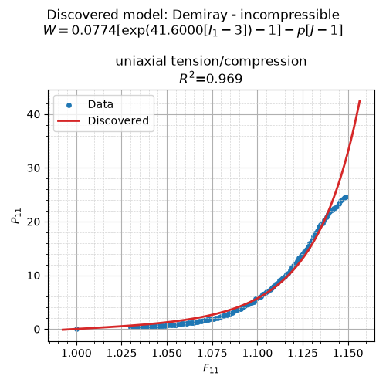

=== Material Fingerprinting ===
Contact moritz.flaschel@fau.de for help and bug reports.
The pickle database is loaded from the package resources.
Database Information:
models in the database:
Blatz-Ko - incompressible
Demiray - incompressible
Gent - incompressible
Holzapfel - incompressible
Mooney-Rivlin - incompressible
Neo-Hooke - incompressible
Ogden - incompressible
number of fingerprints = 2502
uniaxial tension: stretch ranges from 0.1 to 10.0 in the database
Material Fingerprinting Results:
discovered model: Demiray - incompressible
identified parameters: [ 0.07740721 41.6 ]
formula: $0.0774 \left[\exp(41.6000 [I_1 - 3]) - 1\right] - p [J-1]$
R² values per experiment:
uniaxial tension/compression: 0.9690
R² average over all experiments: 0.9690

Paper 2 Figure 8a CF
Paper –

Dataset –
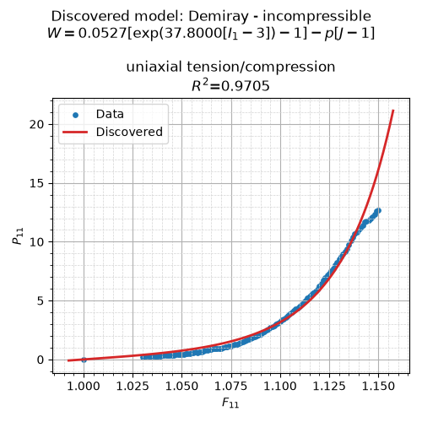

=== Material Fingerprinting ===
Contact moritz.flaschel@fau.de for help and bug reports.
The pickle database is loaded from the package resources.
Database Information:
models in the database:
Blatz-Ko - incompressible
Demiray - incompressible
Gent - incompressible
Holzapfel - incompressible
Mooney-Rivlin - incompressible
Neo-Hooke - incompressible
Ogden - incompressible
number of fingerprints = 2502
uniaxial tension: stretch ranges from 0.1 to 10.0 in the database
Material Fingerprinting Results:
discovered model: Demiray - incompressible
identified parameters: [ 0.05266883 37.8 ]
formula: $0.0527 \left[\exp(37.8000 [I_1 - 3]) - 1\right] - p [J-1]$
R² values per experiment:
uniaxial tension/compression: 0.9705
R² average over all experiments: 0.9705

Fit
import os
import numpy as np
import pandas as pd
import matplotlib.pyplot as plt
from scipy.interpolate import PchipInterpolator

# ==========================================================
# Read Data
# ==========================================================

csv_file = os.path.expanduser("~/Downloads/Paper 1 - CompiledDataset.csv")
df = pd.read_csv(csv_file)

# ==========================================================
# FIBRE DIRECTION
# ==========================================================

x1 = df["Stretch1"].dropna().values
y1 = df["CauchyStress1"].dropna().values

x2 = df["Stretch2"].dropna().values
y2 = df["CauchyStress2"].dropna().values

plt.figure(figsize=(8,6))

# Plot complete datasets (translucent)
plt.plot(
x1, y1,
color="royalblue",
alpha=0.35,
linewidth=2,
label="Fatemifar et al. (2019, ASME)"
)

plt.plot(
x2, y2,
color="crimson",
alpha=0.35,
linewidth=2,
label="Sommer et al. (2015, Annals of Biomedical Engineering)"
)

# Common stretch interval
xmin = max(x1.min(), x2.min())
xmax = min(x1.max(), x2.max())

# Representative curve sampled every 0.001
xx = np.arange(xmin, xmax + 0.001, 0.001)

# Shape-preserving interpolation
f1 = PchipInterpolator(x1, y1)
f2 = PchipInterpolator(x2, y2)

# Average of both interpolated curves
yfit = 0.5 * (f1(xx) + f2(xx))

# Plot representative curve
plt.plot(
xx,
yfit,
color="black",
linewidth=4,
label="Representative Fit"
)

# Save representative curve
fibre_df = pd.DataFrame({
"Stretch": xx,
"CauchyStress": yfit
})

fibre_df.to_csv(
os.path.expanduser("~/Downloads/Fibre_RepresentativeCurve.csv"),
index=False
)

plt.xlabel("Stretch")
plt.ylabel("Cauchy Stress")
plt.title("Fibre Direction")
plt.grid(True)
plt.legend()
plt.tight_layout()

# ==========================================================
# CROSS-FIBRE DIRECTION
# ==========================================================

x3 = df["Stretch3"].dropna().values
y3 = df["CauchyStress3"].dropna().values

x4 = df["Stretch4"].dropna().values
y4 = df["CauchyStress4"].dropna().values

plt.figure(figsize=(8,6))

# Plot complete datasets (translucent)
plt.plot(
x3, y3,
color="forestgreen",
alpha=0.35,
linewidth=2,
label="Fatemifar et al. (2019, ASME)"
)

plt.plot(
x4, y4,
color="darkorange",
alpha=0.35,
linewidth=2,
label="Sommer et al. (2015, Annals of Biomedical Engineering)"
)

# Common stretch interval
xmin = max(x3.min(), x4.min())
xmax = min(x3.max(), x4.max())

# Representative curve sampled every 0.001
xx = np.arange(xmin, xmax + 0.001, 0.001)

# Shape-preserving interpolation
f3 = PchipInterpolator(x3, y3)
f4 = PchipInterpolator(x4, y4)

# Average of both interpolated curves
yfit = 0.5 * (f3(xx) + f4(xx))

# Plot representative curve
plt.plot(
xx,
yfit,
color="black",
linewidth=4,
label="Representative Fit"
)

# Save representative curve
cross_df = pd.DataFrame({
"Stretch": xx,
"CauchyStress": yfit
})

cross_df.to_csv(
os.path.expanduser("~/Downloads/CrossFibre_RepresentativeCurve.csv"),
index=False
)

plt.xlabel("Stretch")
plt.ylabel("Cauchy Stress")
plt.title("Cross-Fibre Direction")
plt.grid(True)
plt.legend()
plt.tight_layout()

plt.show()

print("\nSaved:")
print("~/Downloads/Fibre_RepresentativeCurve.csv")
print("~/Downloads/CrossFibre_RepresentativeCurve.csv")

